Women’s Economic Security survey

Promotional Toolkit

Acknowledgment of Country
We pay our respects to the traditional custodians of this land, past and present, and honour their legacy. The foundations laid by these ancestors—our First Peoples—gives strength, inspiration and courage to current and future generations, towards creating a better Queensland.

Overview
The Department of Women, Aboriginal and Torres Strait Islander Partnerships and Multiculturalism (DWATSIPM) is launching a consultation to inform Queensland’s first Women’s Economic Security Strategy. We want input on the best ways to break down barriers to economic security and create opportunities for women.

Women continue to participate in the workforce at lower rates compared to men and are much more likely to work part-time and access these arrangements to care for children. Women also continue to be over-represented in lower paid roles and industries. This has contributed to Queensland’s gender pay gap of 12.6 per cent, compared with 13 per cent nationally.

Women also continue to face lower superannuation balances, higher rates of insecure work and significant barriers to economic security.

When women’s finances are secure, and they have choice, they can pursue their ambition. That’s the Queensland we are delivering.

Queensland’s economic success depends on the benefits realised from women’s full economic participation and inclusion. Economic security underpins all other elements of equality throughout women’s lives.

Queensland’s first Women’s Economic Security Strategy will be developed with women for women, in partnership with community and industry leaders. It will integrate efforts across government agencies and with other governments, and in our community to address barriers in health, housing, safety, justice, education, employment, and training, and including consideration of the overlays for women with diverse backgrounds and experiences.

The survey is seeking input from Queensland women and girls and representatives of relevant peak bodies, industry groups, community groups and organisations. It will run until February 2026.

About Women’s Economic Security

Key messages
- Consultation for Queensland’s first Women’s Economic Security Strategy is now open.
- The Queensland Government is seeking input on the best ways to break down barriers to economic security and create opportunity for women.
- Economic security is the foundation of aspiration, opportunity and choice. By participating in this survey, you’ll help us write plans to improve outcomes for women in health, housing, safety, education, employment, and more.
- When women’s finances are secure, and they have choice, they can pursue their ambition.
- Despite progress, women in Queensland still face challenges. Have your say and help tackle these issues head-on.
- Queensland’s economic success depends on women having greater opportunities for participation. This strategy will be developed with women, for women, in partnership with community and industry leaders.
- The survey is open until February 2026 and participation is encouraged among:
  - Queensland women and girls 16 and over
  - Queensland peak bodies, industry groups, community groups or organisations
- Share your experiences and help shape the future of women’s economic security at women.qld.gov.au

Social media tag accounts
Tag us on your Women’s Economic Security survey content:
Facebook: @qldwomen
LinkedIn: Women on Boards – Queensland

Promotional Assets
Below you will find a suite of materials to use in promoting Women’s Economic Security survey.

Graphics for social and web
The below images are available for download.
Social tiles
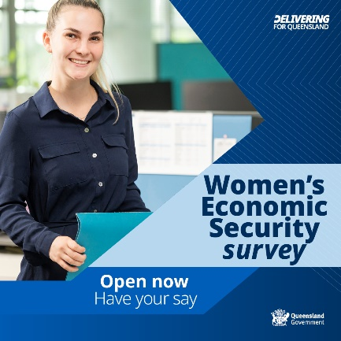 | 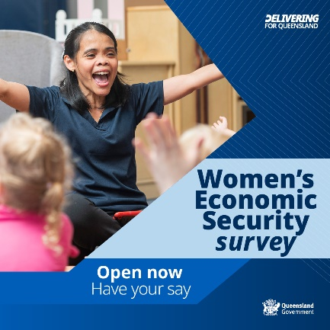 | 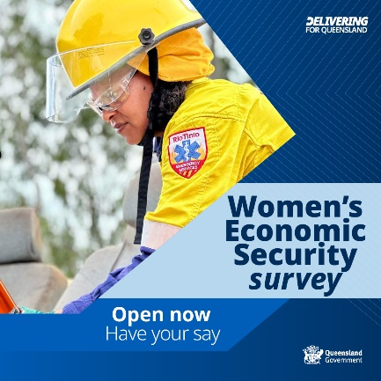
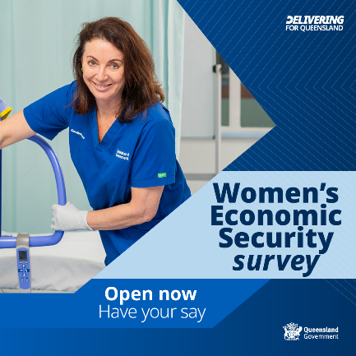 | 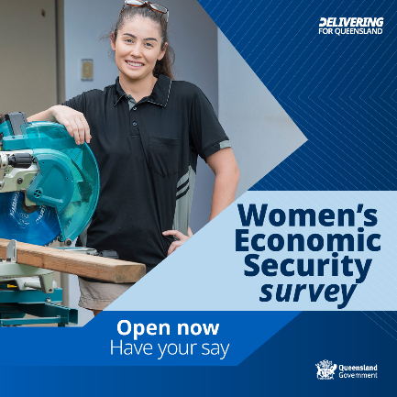

Web / landscape graphic
 | 
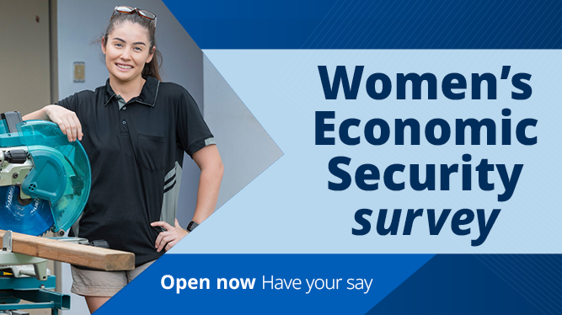 | 

Newsletter header
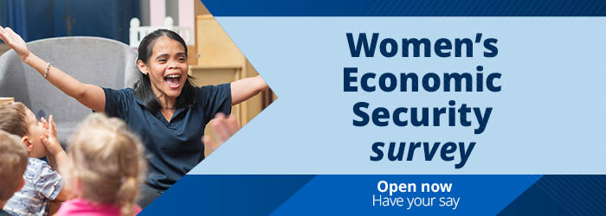

Email content

Email for your network contacts
Send an email to your network, encouraging participation in sharing this initiative.
Subject: Have Your Say: Women’s Economic Security in Queensland
Dear [Recipient's Name],
A statewide consultation to inform Queensland’s first Women’s Economic Security Strategy is now open, and we need your help to spread the word.
When women’s finances are secure, and they have choice, they can pursue their ambition.
Despite significant progress, women in Queensland continue to face persistent challenges.
Economic security is the foundation of aspiration, opportunity and choice. By participating in this survey, you’ll help the Queensland Government write plans to improve outcomes in health, housing, safety, education, employment, and more for women across Queensland.

Queensland’s economic success depends on women having greater opportunities for participation. This strategy will be developed with women, for women, in partnership with community and industry leaders.

We encourage you to share this opportunity with your networks and help ensure voices are heard. The survey is open to all Queensland women and girls until February 2026.
Take the survey online at women.qld.gov.au.
Thank you for your support in shaping the future of women’s economic security in Queensland.
[Your Name]

Newsletter content

Instructions
Copy and paste the copy below into your organisation’s newsletter/eDM. There are two versions — < 250 words and <150 words.

Newsletter/eDM copy — under 250 words

Have your say: help shape Queensland’s first Women’s Economic Security Strategy
The Queensland Government is calling on women and girls across the state to share their experiences and ideas to help shape Queensland’s first Women’s Economic Security Strategy.
While progress has been made, significant challenges remain. Economic security is the foundation of aspiration, opportunity and choice. By participating in this survey, you’ll help us write plans to improve outcomes in health, housing, safety, education, employment, and more for women across Queensland.
Queensland’s economic success depends on women having greater opportunities for participation. This strategy will be developed with women, for women, in partnership with community and industry leaders.
The survey is open to all Queensland women and girls until February 2026. Your voice matters – this is your chance to help shape a future where every woman and girl has the opportunity to thrive.
Take the survey today: women.qld.gov.au
Together, we can create a future where Queensland women have more equitable economic opportunities and choices.

Newsletter/eDM copy — under 150 words
Have your say: building a future where Queensland women and girls have greater opportunities and choices

The Queensland Government is inviting women and girls to share their experiences and ideas to help shape the state’s first Women’s Economic Security Strategy.

While progress has been made, challenges remain.

Economic security is the foundation of equality. This consultation aims to address barriers and improve opportunities in areas like health, housing, safety, education, and employment.

The strategy will be developed with women, for women, in partnership with community and industry leaders.

The survey is open until February 2026. Your voice matters – help create a stronger, more economically inclusive Queensland.

Take the survey today: women.qld.gov.au

Social media copy

👩‍💼 Did you know?
Women in Queensland are more likely to face barriers to economic security. To tackle this, we invite you to share your experiences and ideas on what’s needed to create more economic opportunity for women.
Don’t miss your chance to help shape the state’s first Women’s Economic Security Strategy.
📅 Survey closes: February 2026
💻 Take the survey: women.qld.gov.au
---
Queensland’s first Women’s Economic Security Strategy is in development, and you can help shape it. Share your insights and experiences.
Don’t miss this opportunity to have your say.
📅 Survey open until February 2026.
💻 Take the survey here: women.qld.gov.au
The Queensland Government is developing its first Women’s Economic Security Strategy, and you can help shape it. Share your experiences and ideas to help improve opportunities.
Help pave the way for a future where Queensland women have greater economic opportunities and choices.
📅 Survey open until February 2026.
💻 Take the survey here: women.qld.gov.au
---
Economic security for Queensland women is more than a goal – it’s foundational.
Queensland’s economic success depends on women’s financial security and inclusion. Share your voice in the Women’s Economic Security Strategy survey and help pave the way for a future where women have greater opportunities and choices.
📅 Closes February 2026
💻 Take the survey here: women.qld.gov.au

Further information / enquries
For more information about the Women’s Economic Security Strategy contact:
Strategic Communication and Marketing
Governance and Strategic Communication
Department of Women, Aboriginal and Torres Strait Islander Partnerships and Multiculturalism

Email: communications@dwatsipm.qld.gov.au.

