Promotional Toolkit

Empowering Queensland Women Grants 2026
Acknowledgment of Country
We pay our respects to the Aboriginal and Torres Strait Islander ancestors of this land, their spirits and their legacy. The foundations laid by these ancestors gives strength, inspiration and courage to current and future generations, towards creating a better Queensland.

About the grants
The Empowering Queensland Women (EQW) grants program supports initiatives that improve the economic security of Queensland women and girls.
In 2026, the focus is on addressing barriers to economic security, such as financial literacy, digital skills, career progression, and access to education and training.
Economic security is essential to foster long-term benefits for the whole community.

Funding details
Grants of up to $10,000 (excluding GST) are available for initiatives delivered within six months of commencement.
Funding is for eligible items like resource materials, venue hire, marketing, childcare for initiative participants, and guest speaker fees.
Ineligible expenses include infrastructure purchases, operating costs, prizes, interstate travel, and retrospective costs.

Eligibility
Applicants must be:
- Incorporated not-for-profits, Indigenous corporations, Queensland universities or local government authorities.
- Based in Queensland with an ABN and no outstanding financial or performance issues with the Queensland Government.
- Insured with public liability coverage of at least $10 million.
Ineligible applicants include for-profit entities, unincorporated organisations, sole traders, and state entities like schools and hospitals.

Application Process
Applications open on Friday 13th March 2026 and close 4pm on Monday 13th April 2026. Late or email submissions will not be accepted.
Applications are only received via the SmartyGrants platform. Only one application per organisation will be accepted.

Assessment
Projects should focus on breaking down barriers, engaging diverse groups (such as Aboriginal and Torres Strait Islander women, women with disabilities and women from culturally and linguistically diverse backgrounds) and delivering clear, measurable benefits.
Applications will be reviewed by a panel based on how well the project improves women’s economic security, the organisation’s ability to deliver the project, plans for accessibility and engagement and a clear effective budget.

Resources available
Visit https://www.women.qld.gov.au/eqw to access resources to promote the Empowering Queensland Women (EQW) grants program 2026.
Resources include:
- Key messages
- Social media accounts and hashtags
- Social media posts
- Electronic news/email content
- Newsletter content
- Social media tiles
- Newsletter assets – header and footer
- Poster.

Key messages

- Applications are now open for the Empowering Queensland Women grants
- Eligible organisations can apply for a grant up to $10,000.
- The Empowering Queensland Women grants supports community groups and organisations across Queensland to improve the economic security of women and girls
- The grants aim to address unique issues faced by women and girls to create long-term benefits for individuals and communities.
- Applications close at 4pm on Monday 13th April 2026.
- For more information or to apply visit https://www.women.qld.gov.au/eqw

Promotional assets

Social media
Let us know you’ve shared – tag us on social!
Facebook –
@qldwomen
LinkedIn -
- Department of Women, Aboriginal and Torres Strait Islander Partnerships and Multiculturalism
- Women on Boards - Queensland
Hashtags:
#EmpoweringQLDWomen
#EQW26 #WomeninQLD

Post 1
Are you passionate about supporting women and girls in Queensland? Grants of up to $10,000 are now available for projects that improve women’s economic security and create lasting community impact.
The Empowering Queensland Women grants program is launching 2026 applications ☀️
✅ Open to Queensland-based organisations.
✅ Funding covers resources, venue hire, marketing, and more.
✅ Applications close soon—don’t miss out!
📅 Apply now via SmartyGrants
📞 Need help? Call Women’s Infolink at 1800 177 577.
Let’s work together to empower women and girls across Queensland! 💪 #EmpoweringQLDWomen

Post 2
Got an idea about how to engage your community, raise awareness and address economic barriers for women and girls? The Queensland Government’s Empowering Queensland Women 2026 grants program is now open.
👉 To find out more and to apply, visit https://www.women.qld.gov.au/eqw. Applications close at 4pm on Monday 13th April 2026.
#EmpoweringQLDWomen #EQWgrants #WomeninQLD

Electronic news content
Applications are now open for the 2026 Empowering Queensland Women grants.
A total of $270,000 in grant funding is available to help deliver community events and initiatives that raise awareness and address the important and unique economic issues faced by women and girls.
Eligible Queensland-based organisations can apply for funding of up to $10,000.
Visit https://www.women.qld.gov.au/eqw for more information and to find out how to submit an application. Applications close at 4pm on Monday 13th April 2026.

Newsletter content
The Empowering Queensland Women (EQW) Grant Program is now accepting applications for funding of up to $10,000.
This program is a fantastic opportunity for organisations to make a meaningful impact in their communities through projects that improve the economic security of women and girls across Queensland.
EQW is designed to support empowering projects with a focus on breaking down barriers and creating lasting community impact, especially for those from diverse backgrounds. Whether it’s creating resources, hosting workshops or delivering community programs, this program can help bring your project to life.
Eligible organisations can use the funding for a range of costs, such as resource materials, venue hire, marketing, childcare for initiative participants, and guest speaker fees to support projects that prioritise addressing barriers to economic security through improved financial literacy, digital skills, and access to education and training.
Applications will be assessed on eligibility criteria, including capacity to deliver, accessibility and engagement strategies, and a detailed budget. A panel will review all eligible applications, considering factors such as geographical spread, audience diversity and project sustainability.
To apply applications must be submitted via Smarty Grants by 4pm on Monday 13th April 2026.
If you’re interested in applying but need clarification on the guidelines, assistance is available. Contact Women’s Infolink at 1800 177 577 or email women@qld.gov.au for support. While they can’t provide advice on individual proposals, they can help you understand the application process and requirements.
Don’t miss this opportunity to make a difference in the lives of Queensland women and girls and empower Queensland women – one project at a time.

Social media tiles
Social tile (1080 x 1350)
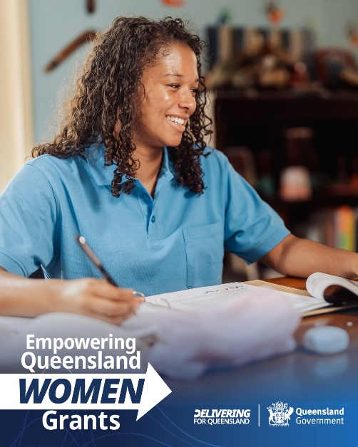
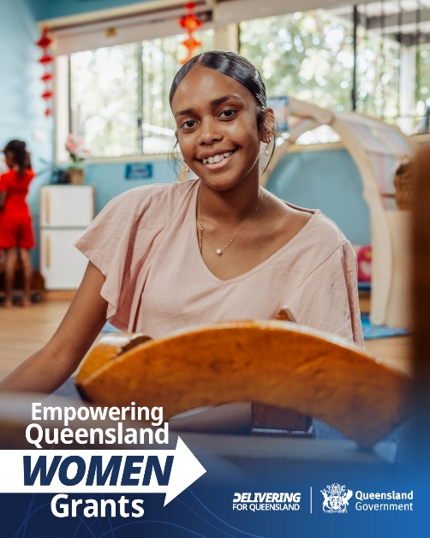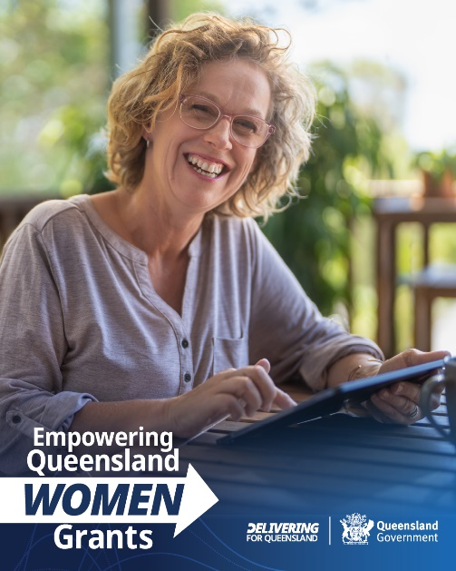

Social tile (1080 x 1080)
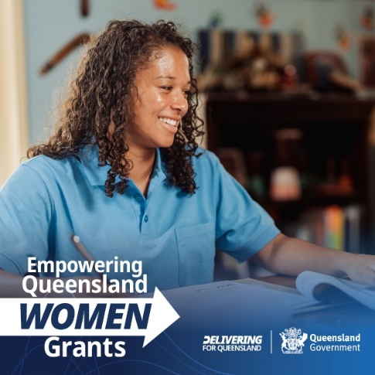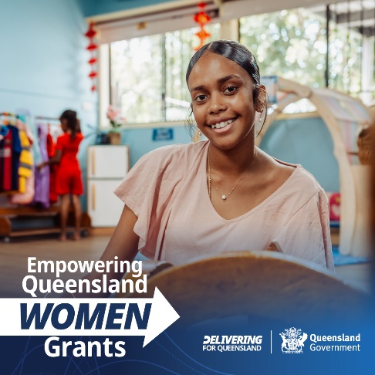

Social tile (1200 x 627)
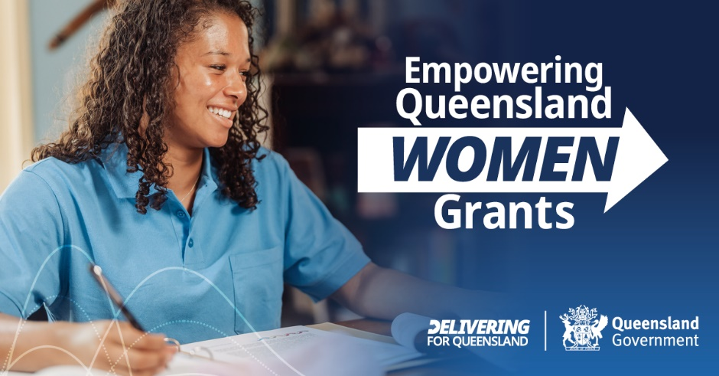


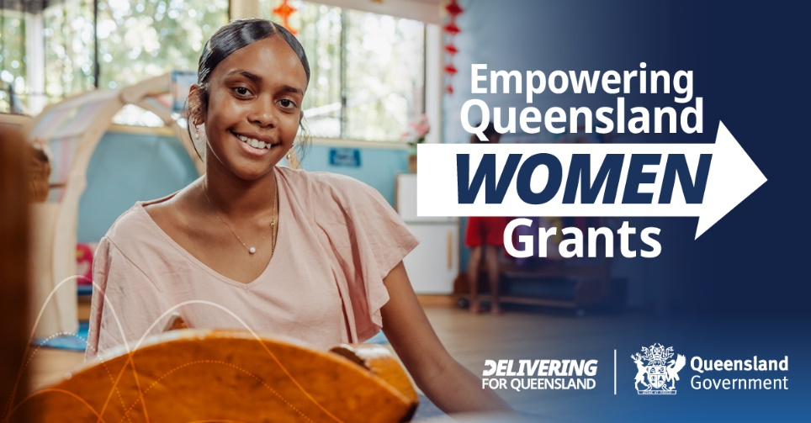

Social tile (627 x 1200)
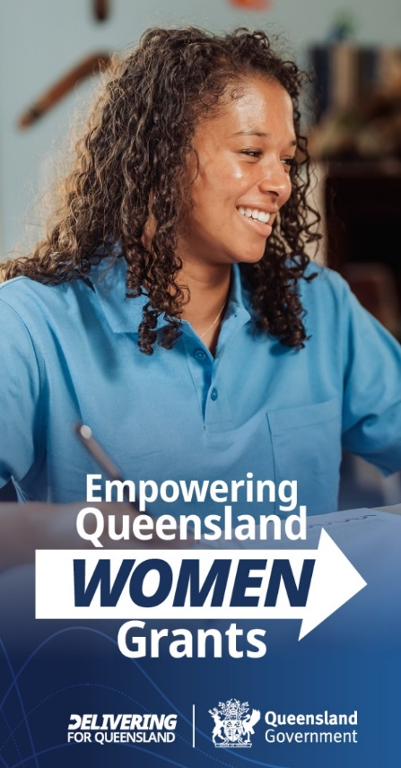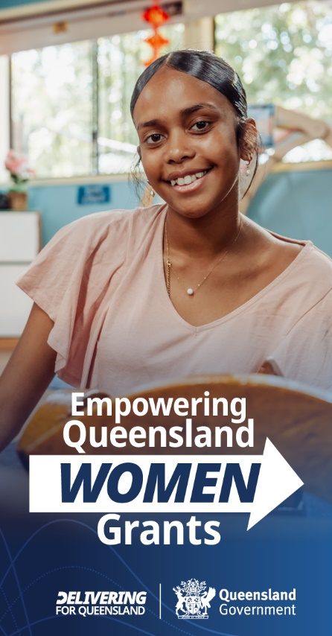

Social frame
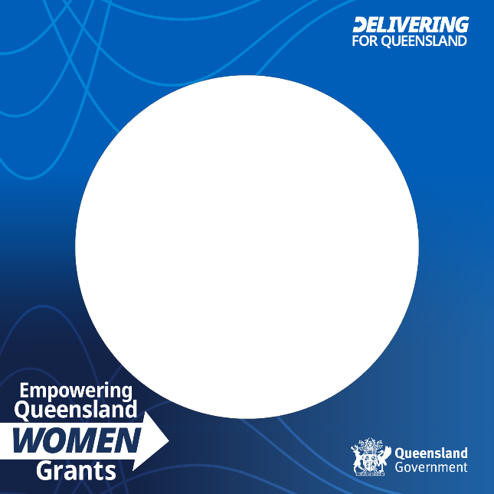

Newsletter assets
Header
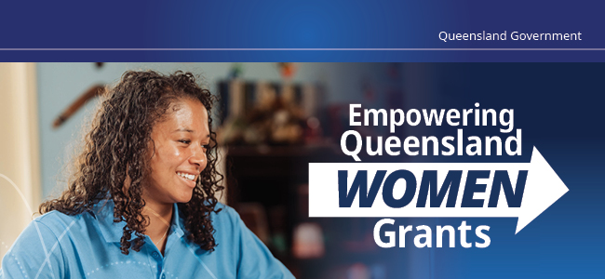

Footer

Poster
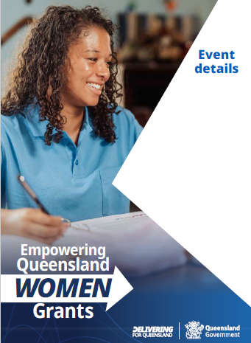

Additional information
For questions about the guidelines, contact Women’s Infolink at 1800 177 577, email women@qld.gov.au or visit www.women.qld.gov.au

