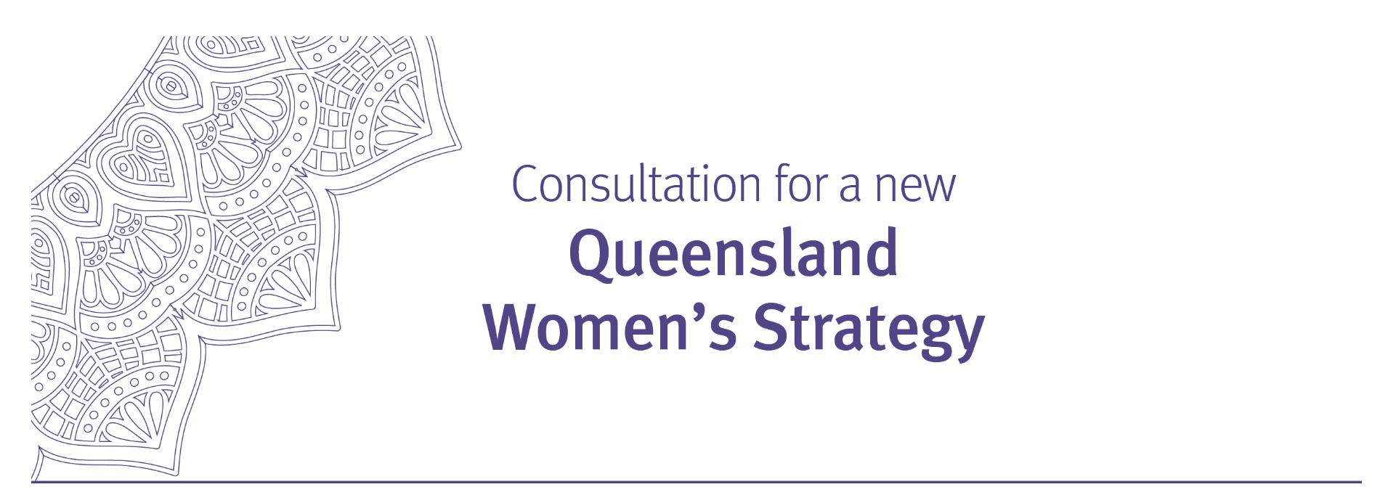

Report on the public consultation

December 2021

Overview
The Queensland Government committed to developing a new Queensland women’s strategy and continuing to lead the whole-of Queensland community’s efforts in advancing the status of women and girls and gender equality. The new women’s strategy will build on the progress and achievements made under the Queensland Women’s Strategy 2016-21.

To capture the voices of Queensland women and girls and the Queensland community as a whole and inform the new women’s strategy, the Queensland Government undertook extensive state-wide community consultation during August – October 2021. A discussion paper was released to facilitate feedback from the community, which outlined key issues impacting on the lives of Queensland women and girls and the Queensland community.

Focus areas
Areas the discussion paper and the consultation activities focused on were:
- Gender equality in Queensland: major progress and achievements made under the Queensland Women’s Strategy 2016-21 and key issues impacting on persistent gender inequalities in Queensland;
- Vision for women, girls and gender equality in Queensland: a new women’s strategy as a future vision for addressing the needs of women and girls and driving gender equality in Queensland; and
- Critical factors for successful delivery of change and achievement of gender equality in Queensland: collective efforts from all stakeholders in driving sustainable and meaningful change and empowerment of diverse women and girls.

Consultation activities
A combination of targeted and open engagement activities were delivered, including:
- community consultation through a ‘Get involved’ online survey;
- an open invitation for written submissions responding to the discussion paper;
- face-to-face forums and meetings with key stakeholders through networks and events;
- a series of meetings with an advisory group consisting of experts, key service providers and representatives from networks and specialist services in the women’s sector seeking their input and advice;
- youth-focused activities including a Youth e-Hub online survey and a youth forum; and
- promotion of consultation activities through social media platforms.

Consultation responses at a glance

- 1,496 survey responses received via Get Involved
- 110 survey responses received via Youth e-Hub
- 99 written submissions received from stakeholders, individuals, and organisations
- 142 postcard responses received
- 20 young people participated in a youth forum
- 20 forums and meetings for targeted consultation with stakeholders
- 4 Queensland Women’s Strategy Advisory Group meetings held for their input and advice
- 123 Facebook comments posted.
*See attachment for further information about consultation activities.

Key findings – summary
- Participants across all consultation activities recognised and appreciated the actions and achievements led by the Queensland Government under the Queensland Women’s Strategy 2016-21.
- Passing legislation to decriminalise termination of pregnancy was identified as the most significant achievement in Queensland in the last five years by three quarters of the respondents to the Get Involved survey.
- Most consultation participants acknowledged women and girls continued to be impacted by persistent gender inequality in Queensland despite recent significant achievements and moves towards gender equality.
- Across all consultation activities, two areas emerged as key priorities: women’s safety from all types of violence (domestic, family and sexual) and women’s financial independence and economic security.
- Participants generally acknowledged the need for greater recognition and support for the challenges experienced by different groups of women and girls, including Aboriginal and Torres Strait Islander women, women in rural, regional and remote areas, women from culturally diverse communities, LGBTIQ+ women, women with disability, older women and young women.
- Most consultation participants supported continued efforts for advancing gender equality in Queensland and agreed that:
- Gender equality is important to, and would improve life for, all genders; and
- Gender equality would make Queensland communities more prosperous, safer and healthier.
- Participants across all consultation activities support Queensland having a new women’s strategy that would be instrumental in advancing gender equality in Queensland.
- Responses indicate that for a new women’s strategy to make positive and sustainable differences to the lives of women and girls, it needs to reflect factors fundamental to addressing gender inequality, including a human rights framework, and continued focus given to women’s economic security, safety, wellbeing and cultural change.
- The majority of participants across all consultation activities felt that the Queensland Government should continue to drive the implementation of a new women’s strategy and lead the advancement of the status of women and gender equality, including playing a key role in:
- creating social, economic, political and cultural conditions required to empower women and girls to participate equally in society;
- playing a leading role in negotiating with the Commonwealth Government and collaborating with other state and territory governments to address gender-based and other forms of marginalisation; and
- implementing best practice as an employer in enabling structural and cultural change to achieve workplace gender equality.
- Consultation participants agreed that collective action is required to make sustainable and meaningful change and achieve gender equality in Queensland, with the non-government sector (workplaces, communities and individuals) being crucial to driving change.
- Flexible work practices, corporate culture change and access to affordable childcare were identified by the survey respondents as key factors for improved workplace gender equality.
- Education emerged across consultation activities as crucial to helping support communities and individuals, including men and boys, to appropriately address gender equality in Queensland.
- Participants across all consultation activities supported greater recognition and celebration of the achievements of Queensland women and the need to hear the voice of diverse women and girls, both of which would be integral to the advancement of gender equality in Queensland.

Key findings – How is Queensland fairing in gender equality?

Major progress and achievements
Participants across consultation activities recognised and appreciated the actions and achievements led by the Queensland Government under the Queensland Women’s Strategy 2016-21.

Of the total 1,496 respondents to the Get Involved online survey, 73.1% (or 1,094) of respondents identified passing legislation to decriminalise termination of pregnancy in 2018 as the most significant achievement in advancing the status of women and girls and gender equality in Queensland (see the graph below for further information).
Graph 1: major achievements and milestones in last five years

Other achievements identified among the survey respondents were the Queensland Government’s investment of more than half a billion dollars in ending violence against women and girls, Queensland becoming the first state to legislate a 10-day paid domestic violence leave for Queensland Government employees and the establishment of the independent Women’s Safety and Justice Taskforce.

Consultation participants also cited Queensland Government initiatives including Skilling Queensland for Work; the Queensland Financial Inclusion Action Plan; continued funding of women’s health and wellbeing services and leadership demonstrated by the Queensland Government’s female leaders, especially during the COVID-19 pandemic such as the former Chief Health Officer, the Premier and other female cabinet members; and the appointment of Queensland’s first Special Commissioner, Equity and Diversity in the Public Service Commission.

Consultation participants also noted cultural change in the Queensland community, such as an increased public awareness of gender inequality and willingness to engage in meaningful debate on gender-based issues impacting on women and girls in the community; greater insight into the adverse impact of domestic and family violence on women and the wider community; emergence of women of all ages speaking out on gender-based issues and challenges such as abuse, harassment, inequality of career progression and the gender pay gap.

Key issues impacting on persistent gender inequalities in Queensland
Most consultation participants acknowledged women and girls continue to be impacted by persistent gender inequality in Queensland despite recent significant achievements and shifts towards gender equality.

Across all consultation activities, two areas emerged to be addressed as priority: women’s safety from all types of violence (domestic, family and sexual) and women’s financial independence and economic security. There was also great emphasis on gender inequality being a key contributing factor to violence against women, non-physical forms of violence, consent and sexual education. Many consultation participants also commented on the lack of recognition and under-valuing of women’s work – paid and unpaid – in social, cultural and monetary terms, hindering women’s economic security.

Of the total 1,496 respondents to the Get Involved survey, almost half of the respondents (44.5%) identified domestic and family violence as a key barrier to achieving gender equality in Queensland, followed by sexual offences such as sexual assault, sexual abuse and rape offences (37.2%), the gender pay gap (33.2%), housing (housing affordability and homelessness) (29.6%) and representation of women in leadership (27.5%). Further information is outlined in the following graph.

Graph 2: issues to be addressed to achieve gender equality

Consultation participants also felt persistent discrimination against women and girls resulted from gender stereotypes and conscious and unconscious gender bias. Consultation participants in the younger age group, and over 90% of the Get Involved survey respondents, agreed that attitudes towards women were different to those towards men. Of the total 110 Youth e-Hub survey respondents, 94.5% agreed gender inequality, sexism or discrimination against women was a concern for young people in Queensland and 84.5% said they have experienced gender inequality.

Consultation participants generally said the COVID-19 pandemic has exposed and worsened gender inequalities. Impacts of the pandemic on women commonly raised were:
- increased exposure to domestic and family violence with increases in severity, incidence, risks or situations;
- increased unpaid domestic and caring responsibilities including support for children’s online school learning while maintaining work responsibilities; and
- poor mental health and overall reduced wellbeing due to stress, loneliness, heightened anxiety, feelings of isolation, income instability and financial hardship, poor work-life balance, and increased responsibilities but reduced access to outside supports.

Participants’ comments acknowledged the need for greater recognition and support for challenges experienced by different groups of women and girls to meet their different needs and situations, including Aboriginal and Torres Strait Islander women, women in rural, regional and remote areas, women from culturally diverse communities, LGBTIQ+ women, women with disability, older women and young women. An older woman provided the following story of her lived experience of housing stress and homelessness.

“I was one of the invisible homeless. This realisation comes with immense shame, and it took me years to realise it was not my fault and that systemic and circumstantial factors can change anyone's life from comfortable and secure to being vulnerable and homeless.
I'd always been financially comfortable. Health issues meant my career came to an abrupt end. This spiralled into a deterioration of my mental health and the end of my marriage. So began my precarious housing experience that lasted for eight years.

I slept on couches, in caravans, moved between family and friends, found temporary rentals through Gumtree, house sat and accepted offers to stay with others in situations that weren't safe or comfortable. I felt helpless, desperate and in a constant state of stress. I wasn't able to stay anywhere long enough to establish connections with health providers to understand my health needs and how to manage them.

I didn't fit the box of having dependent children or escaping domestic violence. The service system didn't see my situation as needing urgent assistance. The first time I tried to access the service system I was turned away. I never tried again.

I felt like Humpty Dumpty, smashed into a million pieces. I couldn't see how I could ever put them back together again."

Key findings – A future vision for women, girls and gender equality

Gender-equal Queensland – what does it look like?
Most consultation participants supported continued efforts in advancing gender equality in Queensland and felt gender equality was important and would make Queensland a better place. Over 90% of the 1,496 respondents to the Get Involved survey agreed as follows:

Graph 3: Queenslanders’ view on gender equality

These views were consistent with those of young people who responded to the Youth e-Hub survey, with 97.3% of the respondents expressing that gender equality was ‘very important or ‘important’ to them. Two-thirds of the respondents also felt ‘hopeful’ or ‘excited’ when they thought about the future of women, girls and gender equality in Queensland.

When envisioning gender-equal Queensland, phrases most used by participants across consultation activities reflected positivity including ‘change’, ‘personal safety’, ‘freedom’, ‘confidence’, ‘fairness’, ‘happiness’, ‘respect’, ‘trust’ and ‘equal opportunities’, with some examples as follows:

“When women and men can see the goodness and value in each other’s being, without judgement, ridicule and need to have power over.” | “Pay equality; Role equality; Real progress towards addressing domestic violence; and Changes in attitudes towards women in general.”
“Young women wouldn’t need to struggle to be taken seriously.” | “.. when we no longer have to talk about equality, we will know we are equal…”

A new Queensland Women’s Strategy – how can it make a positive difference for women, girls and gender equality in Queensland?
Participants across all consultation activities supported Queensland having a new women’s strategy that would be instrumental in advancing gender equality in Queensland, including young people. Over 90% of the respondents to the Youth e-Hub survey and all 20 participants at the youth forum agreed that it was important to have a women’s strategy to promote gender equality in Queensland.

Responses indicated that for a new women’s strategy to make a positive and sustainable difference to the lives of women and girls it needs to reflect factors fundamental to addressing gender inequality. Respondents indicated a new women’s strategy should:
- use a human rights framework, recognising women’s rights are human rights and ensuring diversity, inclusion and empowerment;
- set community standards and define commitments to gender equality;
- enable application of gender perspectives to all aspects of legislation, budget, policy and practice to identify and address gender-based inequalities and bring about systemic change;
- better recognise intersectional discussions and approaches to address the immediate needs of women and girls but also tackle persistent, interconnected barriers to realising women’s rights and gender equality, including for those women who are more likely to face additional and entrenched challenges and disadvantages due to various factors and circumstances (including different life stages, geographical locations, caring responsibilities, disability, sexual orientation and gender identify, and cultural and linguistic diversity);
- give distinct consideration to Aboriginal and Torres Strait Islander women/First Nation women (e.g. a commitment to align with the findings of the, Wiyi Yani U Thangani report);
- measure, report and evaluate progress and outcomes, including progress and outcomes for diverse groups and communities of women; and
- continue to work on improving the social and economic position of women and creating positive future opportunities for women and girls.

Issues identified by the consultation participants to be the focus/priorities of a women’s strategy were centred on women’s economic security, safety, wellbeing and cultural change with specific examples being:
- economic rights and equal opportunity for women to participate and develop in the labour market; value of women’s unpaid work; the gender pay gap and gender superannuation gap; opportunities in male-dominated fields of education and industries; flexible work practices; housing affordability and risks of homelessness; women’s financial literacy at all stages of life; access to affordable childcare and support for women returning to work;
- gender-based violence in both public and private spaces, including non-physical violence, sexual and reproductive coercion, and sexual consent;
- better health care support and services for women and girls including mental health at all stages of life;
- education and training for all genders and all age groups implemented across society (schools, workplaces and in the public venues) with focus on gender equality, respectful relationship and discrimination; and
- representation of women in leadership and female role models in all levels of society.
Many participants across all consultation activities felt that the Queensland Government should continue to drive the implementation of a new women’s strategy and lead the advancement of the status of women and gender equality. Almost all respondents (99.5%) to the Get Involved survey agreed that it is important for governments to consider impacts of policies, programs and services on all genders.

The following key roles and responsibilities of the Queensland Government emerged as priorities across the consultation activities:
- creating the social, economic, political and cultural conditions required to empower women and girls to participate equally in society;
- as a legislative body, amending and/or establishing a legal framework to improve the status of women and girls and gender equality such as passing legislation to decriminalise termination of pregnancy, and a review of Queensland’s industrial relations laws and the review of the Industrial Relations Act 2016 (QLD) regarding equal remuneration;
- committing to a gender-responsive approach to all aspects of legislation, budget policy and practice (e.g. a State gender equitable procurement policy, a State gender-responsive budget, gender neutral language used in government policies and forms);
- raising public awareness of gender equality (effects and benefits) through education and training programs;
- leading/facilitating better engagement and partnership with non-government sectors (women’s sector, businesses, industry, community groups and organisations) including ensuring greater involvement of women with lived experience in matters affecting them;
- providing funding or delivering major initiatives and strategies to support women and girls to achieve gender equality in Queensland, such as a Women’s Health Strategy for the state;
- playing a leading role in negotiating with the Commonwealth Government and collaborating with other state and territory governments to address access to affordable childcare, gender discrimination and other forms of marginalisation such as housing and homelessness reforms, the paid parental leave scheme (e.g. eligibility and entitlements), and superannuation contributions/retirement income; and
- implementing best practice as an employer in enabling structural and cultural change in workplaces such as addressing gender pay gap in the public sector, leading a campaign to raise awareness of gender inequality in the workplace and, implementing the Respect@Work report recommendations directed towards the Queensland Government.

Key findings – What are the critical factors to best drive change?

Everyone has a role to play in achieving gender equality – workplaces, communities and individuals
Consultation participants supported collective actions to make sustainable and meaningful change and achieve gender equality in Queensland. Across all consultation activities it was noted non-government sectors such as businesses and community organisations can play an important role in driving change. For example, 92.6% of respondents to the Get Involved survey agreed that non-government sectors should do more to help women achieve leadership roles.

Almost two-thirds of the Get Involved survey respondents (60.8%) believed flexible work practices for both women and men would contribute to improved gender equality in workplaces. Other issues for workplace gender equality were corporate culture change (47.5%) and improved access to affordable childcare (46.9%) (refer to Graph 4 for further information). These three issues were also identified as key factors for workplace gender equality by the Youth e-Hub survey respondents.

Graph 4: issues contributing to workplace gender equality

Strategies to improve gender equality in the workplace, as identified by consultation responses include:
- to incorporate gender-equal workplace culture/values into workplace policies and employee and stakeholder contracts;
- initiate change to ‘workplace practice’ culture and policies on recruitment, training and retention, for example improving the recruitment, training and retention of female apprentices and workers in male-dominated occupations and industries through strategies such as targets and quotas;
- develop and implement workplace policies on sexual harassment and other forms of
gender-based violence (e.g. strengthened codes of practice, behaviour guidelines); and
- collaborate with other businesses through roundtable forums and information sessions to better understand, recognise and support the needs and challenges facing female workers and female business-owners.

Education emerged across consultation activities as crucial to helping support communities and individuals to contribute towards gender equality in Queensland. Comments were made supporting more gender education and programs to promote gender equality in schools, workplaces, families and the wider community with a diverse scope of topics including respect towards women and girls, the benefits of women in leadership, healthy relationships, gender-based violence, gender stereotypes and gender-inclusive language, gender identity.

Some respondents listed more funding for community counselling, specialist support services and free education and training for skill development. Emphasis was placed on strategies for greater involvement of First Nations and culturally and linguistically diverse communities in advancing gender equality, and taking a place-based approach to accommodate different challenges faced by different communities in the advancement of gender equality.

To better engage men and boys for gender equality in Queensland, the consultation participants supported education programs with an emphasis on respecting and valuing women and girls; better understanding of gender roles and stereotypes; and addressing gender issues in schools
(e.g. making gender equality part of the school curriculum). Responses also supported building knowledge, skills and capacity at the organisational and social level across multiple sectors
(e.g. education, businesses, family, religion, sport and other groups and organisations) to develop and deliver primary prevention work with men and boys.

Recognition of the achievements of leading Queensland women
Many participants across consultation activities supported greater recognition and celebration of the achievements of Queensland women as an integral part of the advancement of gender equality. The following suggestions were provided on how to recognise them, including:
- expanding on annual award ceremonies (i.e. International Women’s Day, Queensland Women’s Week) and increasing the numbers of celebrations for different achievements at a state and/or community level, ensuring that women and girls from different levels of society were recognised;
- sharing the stories and experiences of women and girls through diverse media avenues (television and social media) and the education system;
- recognising leading women through public monuments and statues, public art works, historic records, road names, infrastructure and parks;
- ensuring that quiet achievers, small achievements, and community champions were also celebrated and recognised; and
- leveraging the 2032 Summer Olympic and Paralympic Games to consolidate, recognise and celebrate women’s contribution to Queensland.

When asked about which Queensland women to recognise, most mentioned was Dr Jeannette Young, Governor of Queensland and the former Chief Health Officer, often praised as “a legend”, “inspirational”, and “incredible”. Other names commonly provided were Premier Annastacia Palaszczuk, Dame Quentin Bryce, former Governor-General of Australia, Dame Annabelle Rankin, former High Commissioner to Australia and New Zealand, and Aunty Jean Phillips, a senior Aboriginal Christian Leader. Consultation participants also sought recognition of various roles and responsibilities of women such as mothers, working mothers, nurses, teachers, childcare workers, females leaders in politics, business, academia, judiciary and the community, Indigenous female leaders, domestic violence survivors, female sport athletes and coaches and young Indigenous women.

Voices of diverse women and girls
Many participants across all consultation activities supported the need to hear the voice of diverse women and girls to best drive the advancement of gender equality in Queensland. Measures suggested by the participants included:
- actively seeking equal representation of women and girls of all cultural backgrounds and identities across all aspects of Queensland society (i.e. implementation of appropriate interventions on specific issues such as strategies for greater participation and leadership (e.g. diversity targets or quotas), developing and building capacity to address loneliness and social isolation, employment, leadership, health and well-being);
- continual improvement of legislation to reflect and recognise diversity;
- increasing the overall representation of women in leadership roles and opportunities in many spheres of life (including social media and traditional media platforms);
- effective use of media and community campaigns/events to increase awareness of the importance of diverse views; and
- supporting educational institutions, community leaders and groups/organisations in their efforts to recognise and lift diversity (such as inclusive education, diversity awareness programs, community support and forums, grassroots coaching and mentoring).

ATTACHMENT

Analysis methodology
The Office for Women and Violence Prevention, Department of Justice and Attorney-General engaged a temporary contractor for five weeks (8 November – 10 December 2021) to assist in analysing and preparing a report on the information gathered during the public consultation period.
The contractor adopted text mining techniques that use natural language processing and algorithm methodology to capture ‘voices from both the majority as well as minority responses’. Techniques applied include word cloud, word frequency, sentiment analysis, term correlation network,
POS-Tagged phrase frequency, topic modelling (LDA and STM), TF-IDF, TextRank, RAKE, and LexRank. The analysis was completed by R programming language and RStudio.
This consultation report draws on the results delivered by the contractor.

An online survey via Get involved
An online community survey accessible via the Queensland Government’s Get Involved site was available between 11 August 2021 and 8 October 2021. 1,496 responses were received from the respondents throughout the state:
- Most respondents were females (93%), followed by males (5.7%), non-binary (0.9%), and
self-describe (0.4%).
- 90.1% of the responses came from the age group of 26-65 years with the majority of the responses coming from two age groups of 46-55 years (27.3%) and 36-45 years (26.9%).
- Most of the respondents indicated they were living in South East Queensland and other coastal suburbs (see the yellow dots in the map below for the location of the respondents, noting the map only shows the rough location of 80% of the respondents based on available geographical information.)
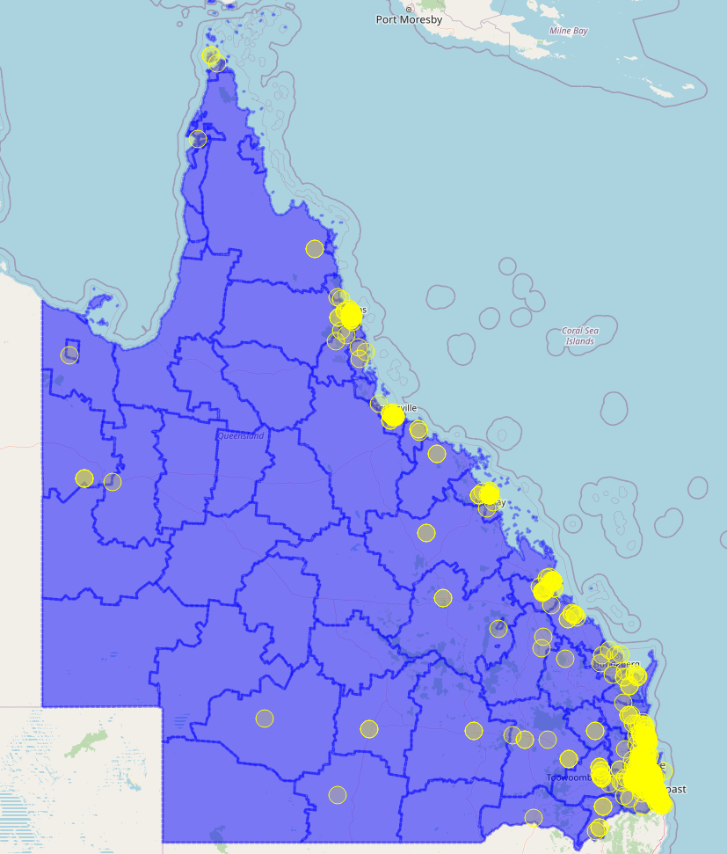

Written submissions
Visitors to the Queensland women’s strategy consultation site were also given an option to respond via written submissions to questions outlined in the consultation discussion paper. Ninety-nine submissions were received from 13 individuals and the following organisations.

- Financy
- Tim Fairfax Family Foundation
- Lateral Project Management
- People with Purpose
- Making work absolutely human (mwah)
- Presence Communications
- Social Impax
- Clear Insurance
- Leina and Fleur
- Prescience
- Femeconomy
- Mindsettle
- Iyengar Counselling Services
- Hutchies
- Fempire
- Purple Playground Pty Ltd
- Middle East Connect and Cultural Advisors
- Pronto Translations
- Queensland Alliance for Mental Health
- Vulcana Women's Circus Inc
- Many Genders One Voice
- IWD Brisbane Meanjin
- Ending Violence Against Women Queensland
- Property Council of Australia
- Queensland Resources Council
- Gold Coast Feminists
- Zonta Club of Ipswich Inc
- Independent Education Union
- Good Shepherd
- PwC Australia
- Queenslanders with Disability Network Ltd
- Australian Longitudinal Study on Women's Health
- University of the Sunshine Coast
- Queensland Law Society
- Australian Red Cross
- One Woman Project
- Older Women's Network (Qld) Inc
- Anglicare Southern Queensland
- The Centre for Women & Co.
- The Salvation Army
- Queensland Nurses and Midwives’ Union
- yourtown
- The University of Queensland (Global Engagement and Entrepreneurship)
- QSuper
- Legal Aid Queensland
- Queensland Rural, Regional and Remote Women's Network Inc.
- Kyabra
- Queensland Catholic Education Commission
- Community Services Industry Association
- Public Health Association of Australia
- Chamber of Commerce and Industry Queensland
- Tennis Queensland
- Queensland Families and Communities Association
- Chief Executive Women
- Australia's National Research Organisation for Women's Safety
- ARC Centre of Excellence for Engineered Quantum Systems
- Carers Queensland
- Together
- Centacare
- Gold Coast Centre against Sexual Violence Inc.
- Respect Inc.
- Mercy Community
- Soroptimist International of Brisbane Inc.
- Marie Stopes Australia
- Multicultural Australia
- YWCA Australia
- National Association of Women in Construction Queensland
- Queensland Council of Unions
- Women’s Health Queensland Inc.
- Respect Inc.
- Sisters Inside Inc.
- Queensland Women’s Health Network Inc.
- Women’s Health Services Alliance Queensland
- True Relationships and Reproductive Health
- Maternity Consumer Network
- Children by Choice
- QENDO
- Micah Projects
- Friends of the Birth Centre
- Homebirth Queensland
- Maternity Choices Australia
- Lutheran Services
- Multicultural Australia Disability Queensland"
- Massage & Myotherapy Australia
- Equal Reality
- People Tech Revolution
- Kinspace
- Utano Consulting
- Queensland Council of Social Service
- Australasian Institute of Mining and Metallurgy
- Hervey Bay Neighbourhood Centre
- The Empty Cradle and WomenHood Counselling
- Our Watch
- Australian Industry Group
- North Queensland Women’s Legal Service
- Sex Discrimination Commissioner, Australian Human Rights Commission
- Rape and Domestic Violence Services Australia
- Of One Mind
- Aboriginal and Torres Strait Islander Legal Service
- National Council of Women of Queensland

An online survey via Youth e-Hub
An online survey was hosted on the Queensland Government youth e-Hub website between
22 September 2021 and 8 October 2021:
- Total 110 responses were received with the majority of the respondents (96 or 87.3%) being female, followed by non-binary (7.3%) and male (5.5%).
- Nearly three-quarters of the respondents (73.6%) were in the 18-25 years age group, followed by the 13-17 years age group (10%).
- Majority of the respondents identified as ‘neither Aboriginal nor Torres Strait Islander’ (93.6%), indicated being born in Australia (88.2%), not having disability (81.8%) and speaking English at home (91.8%).

A youth forum
The Office for Women and Violence Prevention held a youth forum on 7 October 2021 at the State Library of Queensland to engage young people in consultation for a new women’s strategy. A total of 20 young Queenslanders aged 12 to 25 years attended the forum joined by Honourable Shannon Fentiman, Attorney-General and Minister for Justice, Minister for Women and Minister for the Prevention of Domestic and Family Violence and facilitated by Dr Elise Stephenson.

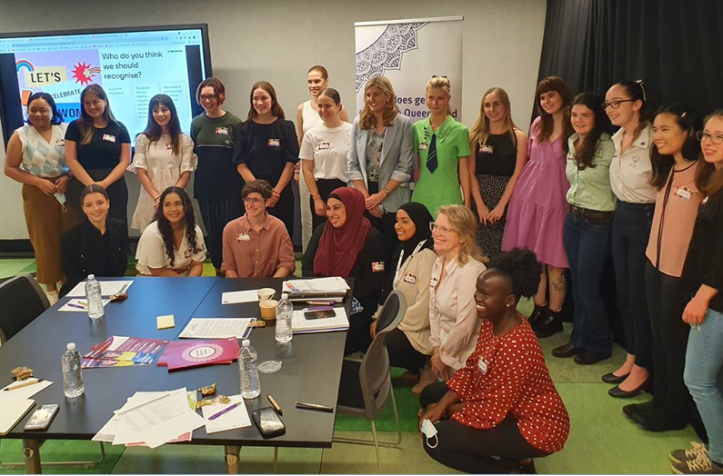

Figure 1: participants at the Youth Forum

Queensland Women’s Strategy Advisory Group
An advisory group was established to provide advice and input to the consultation activities and development of a new Queensland Women’s Strategy. The advisory group consisted of 17 experts, key representatives from networks and specialist services in the women’s sector. The advisory group hosted by the Honourable Shannon Fentiman, Attorney-General and Minister for Justice, Minister for Women and Minister for the Prevention of Domestic and Family Violence met four times on
24 August, 3 November and 13 December 2021 and XX January 2022 (TBC).

The advisory group members were a representative of the following organisations:

- National Aboriginal and Torres Strait Islander Women’s Alliance
- Of One Mind
- Queensland Rural Regional and Remote Women’s Network
- Queensland Council of Social Service
- National Association of Women in Construction Queensland
- YWCA
- Multicultural Australia
- Queensland Council of Unions
- Queenslanders with Disability Network
- Techgirls Movement Foundation
- Women’s Health Queensland
- YFS Logan
- Queensland Women in Business
- Australian Industry Group
- Chamber of Commerce and Industry Queensland
- Deloitte/Accenture
- Community Services Industry Association

Community forums, network meetings or events
The Office for Women and Violence Prevention undertook over 20 face-to-face targeted consultations through its networks meetings or stakeholder events to promote the consultation for a new Queensland women’s strategy and seek feedback. Participating event hosts included: Community Services Industry Alliance, YMCA Community Engagement Chats, Housing Outcomes for Older Women workshop, Queensland Resources Council, QSuper and National Association of Women in Construction Queensland.

Responses to postcards
One hundred and forty-two text-based postcard responses were completed at face-to-face consultations where some participants provided their feedback in response to the broad questions posed - What would gender equality look like and what needs to happen to make gender equality a reality in Queensland?

Social media – Facebook posts
A total of 123 comments were made on posts on the Facebook pages of Queensland Women, the Queensland Government, Minister Fentiman, Domestic and Family Violence Prevention Queensland, Queensland Youth, Justice Queensland, and DV Connect.

